Appendix 'H'

Local Health Profile

The two proposed temporary sites in Lancashire to explore for shale gas extraction is situated within the Fylde district, as seen below:

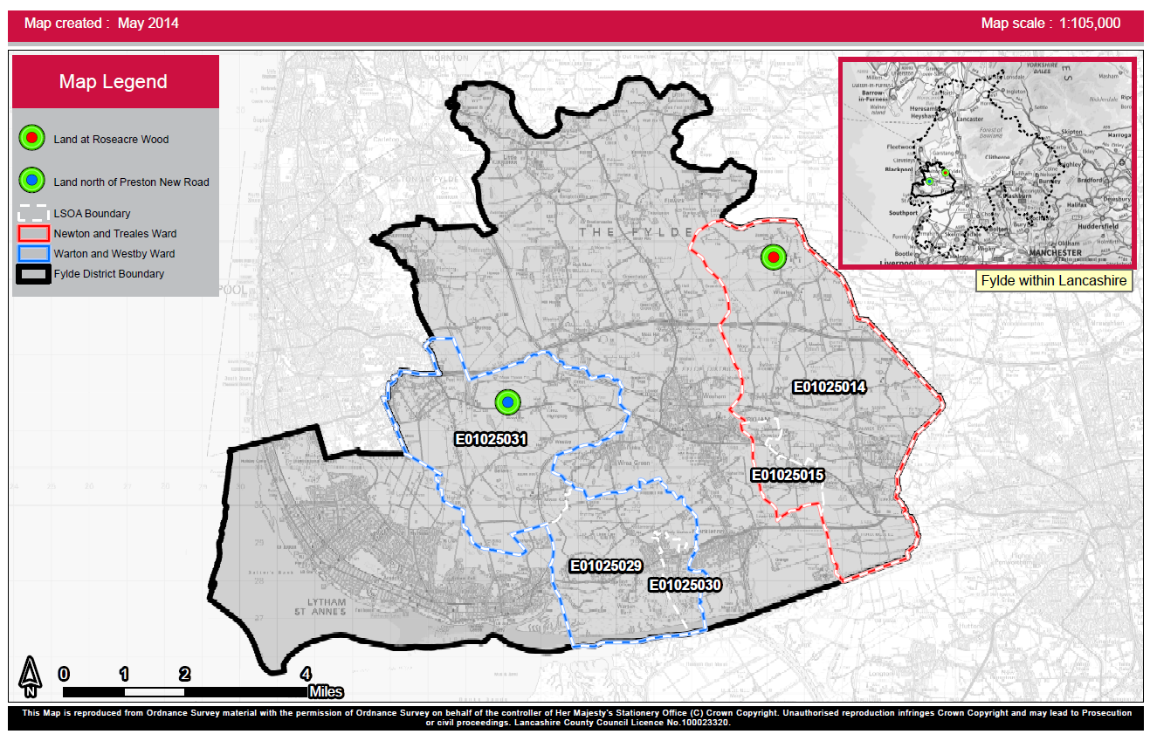

Proposed temporary Site: Roseacre Wood in Lancashire

The proposed temporary Roseacre Wood in Lancashire site is situated within the Newton and Treales ward of the Fylde district, on the east side boarding with the Preston and Wyre districts.. In 2013, the Office for National Statistics (ONS) estimated that this ward had a total population of 3,160, with 49% (1,560) of residents aged 40 to 69 years old and 51% of the population estimated to be females. An age gender breakdown of the population estimate shows that this ward has higher estimated proportions of residents aged between 10 to 14 years old and aged 40 to 74 years old compared to England as a whole (Figure 2).

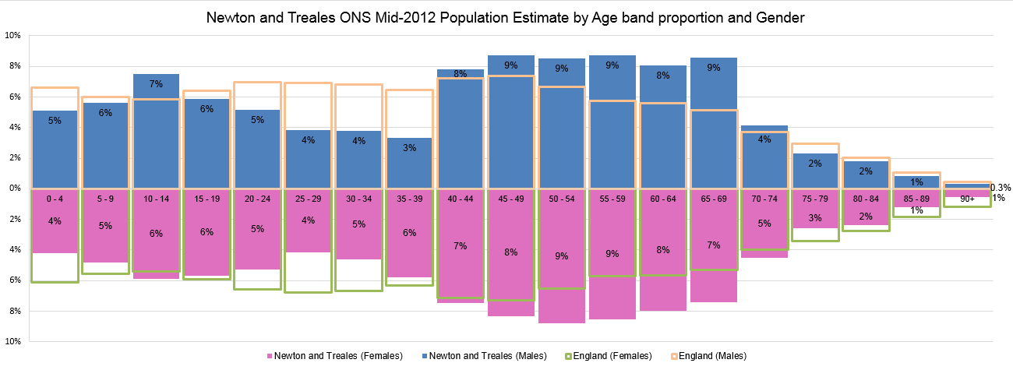
Figure 2: Newton and Treales ONS Mid-2012 Population Estimate by Age band proportion and Gender

Using the MOSAIC Public Sector Profiler produced by Experian, 29% of the population was classed in Group G: Rural Reality. This referred to people who live in rural communities and generally own their relatively low cost homes. Their moderate incomes come mostly from employment with local firms or from running their own small businesses.

A further 28% of residents were classed in Group A: Country Living, which referred to people as being considered to be well-off homeowners, who lived in the countryside often beyond easy commuting reach of major towns and cities. Some people were landowners or farmers, others ran small businesses from their homes, some were retired and others commuted distances to professional jobs.

Using Public Health England's Local Health profile tool, the Newton and Treales ward has the highest life estimated life expectancy at birth (2008-12) for females in the Fylde district of 89 years old. The England national average was 83 years old. For males the ward has a life expectancy at birth (2008-12) of 79, which again is one of the highest estimates in the district and in line with the England national average, across all wards, of 79 years old.

The Environment and Health Atlas for England and Wales is an independent publication produced by the UK Small Area Health Statistics Unit (SAHSU). It is part of the MRC-PHE Centre for Environment and Health and is funded by the Medical Research Council and Public Health England. It was published in April 2014 and shows the relative risks for a 25 year period (1985-2009), for a number of health conditions. The relative risks represent the risk of an area (ward) relative to average risk in England and Wales. These are adjusted for age, deprivation and chance fluctuations due to small numbers.

Using the atlas, the Newton and Treales have above average relative risk for females, for the following conditions:

- Bladder Cancer;
- Chronic obstructive pulmonary disease (COPD);
- Heart Disease;
- Liver Cancer;
- Low Birth Weight;
- Lung Cancer;
- Mesothelioma Cancer;
- Sill births; and
- Skin Cancer.

And for males it is estimated to have above average relative risk for the following areas:
- Chronic obstructive pulmonary disease (COPD);
- Heart Disease;
- Liver Cancer; and
- Lung Cancer.

All-cause mortality is a fundamental and probably the oldest measure of the health status of a population. It represents the effect of the prevalence of risk factors, prevalence and severity of disease, and the effectiveness of interventions and treatment. Differences in levels of all-cause mortality may reflect health inequalities between different population groups.

The Local Health profile tool enables comparisons to the standardised mortality ratio (SMR) for this ward against not only the ratio of the other wards from the district but also against the Fylde district as a whole ratio, the Lancashire county ratio and the England national ratio. Looking at the ratio for all-cause mortality, All-cancers, All-circularly diseases, Coronary heart disease, Stroke and Respiratory diseases the ward had a significantly better ratio than the England national average for all-cause mortality and Respiratory diseases (Figure 3).

Figure 3: Newton and Treales, Causes of death, all ages, standardised mortality ratios (SMRs), 2008-12)
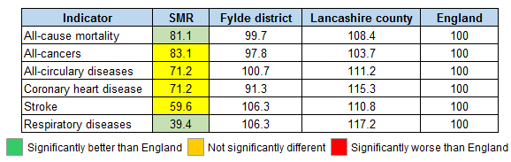
Looking at the premature mortality ratios, the ward was not reporting any significantly different ratios to the England national average.

Proposed temporary Site: Preston New Road in Lancashire site

The proposed temporary Preston New Road in Lancashire site is situated within the Warton and Westby ward of the Fylde district, situated fairly centrally within the district and boarding with the River Ribble to the South and the Blackpool district to the North. In 2013, the Office for National Statistics (ONS) estimated that this ward had a total population of 4,736, with 44% (2,104) of residents aged 45 to 74 years old. An age gender breakdown of the population estimate shows that this ward has higher estimated proportions of residents aged between 45 to 84 years old than England as a whole (Figure 4).

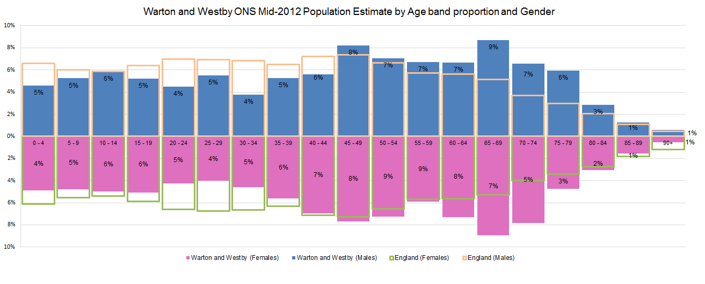
Figure 4: Newton and Treales ONS Mid-2012 Population Estimate by Age band proportion and Gender
Using the MOSAIC Public Sector Profiler, 19% of the population is categorised in Group A: Country Living, which referred to people considered to be well-off homeowners, who lived in the countryside often beyond easy commuting reach of major towns and cities. Some people were landowners or farmers, others ran small businesses from home, some were retired and others commuted distances to professional jobs.

17% were classed in Group F: Senior Security, which relates to elderly singles and couples who lived independently in comfortable homes that they own. Property equity gives them a reassuring level of financial security. This group included people who have remained in their family homes after their children have left, and those who have chosen to downsize to live among others of similar ages and lifestyles.

Additionally, 14% of the population were classed in Group E: Suburban Stability, considered to be typically mature couples or families, some enjoying recent empty-nest status and others with older children still at home. They live in mid-range family homes in traditional suburbs where they have been settled for many years.

Using Public Health England's Local Health profile tool, the Warton and Westby ward has one of the highest life estimated life expectancy at birth (2008-12) for males in the Fylde district of 80 years old. The England national average was 79 years old. For females the ward has a life expectancy at birth (2008-12) of 82 years old and although this is one of the lower estimates in the district, it is in line with the England national average, across all wards, of 83 years old.

The Environment and Health Atlas for England and Wales, reports that the Warton and Westby ward has above average relative risk for females, for the following conditions:

- Bladder Cancer;
- Chronic obstructive pulmonary disease (COPD);
- Heart Disease;
- Liver Cancer;
- Lung Cancer;
- Mesothelioma Cancer;
- Sill births; and
- Skin Cancer.

And for males it is estimated to have above average relative risk for the following areas:
- Chronic obstructive pulmonary disease (COPD)
- Heart Disease
- Liver Cancer

Looking at the latest all-age mortality ratios, using the Local Health profile tool, this ward was not reporting any significantly different standardised mortality ratios (SMR), for any of the conditions examined (Figure 5).

Figure 5: Warton and Westby, Causes of death, all ages, standardised mortality ratios (SMRs), 2008-12)
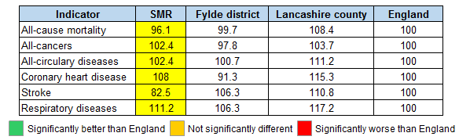
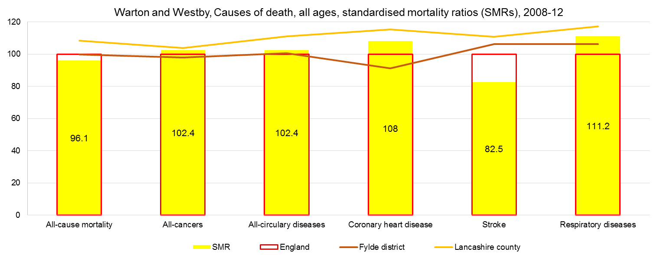
The situation was the same with the premature mortality figures, with the ward not reporting any significantly different SMRs from the England national ratios.

F.

A separate profile of people living within 2 and 5 mile radius is described below.
Proposed Site: Plumpton Hall Farm

2 mile radius

The population within a 2 mile radius is 4,332.A little more than half of them are women. The population density of the area is 20 people per hectare. There are 922 people aged 0-19 years old within a 2 mile radius. They make up 21.3% of the area population. There are 2,384 people aged 20 to 64 years (55% of the population). 1,026 people are aged 65 and over (23.7% of the population).

Total population | Males | Females | Area (hectares) | Population density | 0-19 | 20-64 | 65 and over
4,332 | 2,108 | 2,224 | 3,545 | 19.9 | 922 | 2,384 | 1,026

Most of the population (3,331 people, 77%) did not have long-term conditions or health problems that limited their day-to-day activities. 482 people (11%) had day-to-day activities limited a lot and a further 519 (12%) people had them limited a little. Most of the population (3,329 people, 76.8%) had very good or good health. 324 people (7.5%) had very bad or bad health.

Day-to-day activities limited a lot | Day-to-day activities limited a little | Day-to-day activities not limited | Health – very good | Health – good | Health – fair | Heath – bad | Health – very bad
482 | 519 | 3,331 | 1,792 | 1,537 | 679 | 254 | 70

The population aged 16 to 74 years within a 2 mile radius is 3,164. 416 people (13%) are employed full-time and 718 are retired (22.7%). 940 people (29.7 %) are unemployed.

All usual residents aged 16 to 74 | Economically active; employee; full-time | Economically active; unemployed | Economically inactive; retired
3,164 | 416 | 940 | 718

Mosaic analysis: 1,902 households (Mosaic)

Group 'country living', is dominant (23%) (483 households) for households.
Described as well-off owners in rural locations enjoying the benefits of country life. The key features are:
- Rural locations;
- Well-off homeowners;
- Attractive detached homes;
- Higher self-employment;
- High car ownership; and
- High use of Internet.

Second group at 19.1% is 'prestige positions', described as established families in large detached homes living upmarket lifestyles. (363 households). The key features are:
- High value detached homes;
- Married couples;
- Managerial and senior positions;
- Supporting students and older children;
- High assets and investments; and
- Online shopping and banking.

5 mile radius

The population within a 5 mile radius is 196,510. A little more than half of them are women. The population density of the area is 55 people per hectare. There are 42,917 people aged 0-19 years old within a 2 mile radius. They make up 22% of the area population. There are 112,814 people aged 20 to 64 years (57.7% of the population). 40,779 people are aged 65 and over (20.9% of the population).

Total population | Males | Females | Area (hectares) | Population density | 0 - 19 | 20 - 64 | 65 and over
196,510 | 96,086 | 100,424 | 18,201 | 55.27 | 42,917 | 112,814 | 40,779

Most of the population (149,960 people, 76.3%) did not have long-term conditions or health problems that limited their day-to-day activities. 23,521 people (12%) had day-to-day activities limited a lot and a further 23,029 (11.7%) people had them limited a little. Most of the population (149,187 people, 76%) had very good or good health. 15,719 people (8%) had very bad or bad health.

Day to day activities limited a lot | Day to day activities limited a little | Day to day activities not limited | Health – very good | Health – good | Health – fair | Heath – bad | Health – very bad
23,521 | 23,029 | 149,960 | 82,769 | 66,418 | 31,604 | 12,157 | 3,562

The population aged 16 to 74 within a 5 mile radius is 143,128. 20,040 people (14%) are employed full-time and 25,237 are retired (17.6%). 7,106 people (5%) are unemployed.

All Usual residents aged 16 to 74 | Economically active; employee; full-time | Economically active; unemployed | Economically inactive; retired
143,128 | 20,040 | 7,106 | 25,237

Mosaic analysis: 92,274 households (Mosaic)

Group 'transient renters' is dominant (15.4%) (14,245 households) for households within a 5 mile radius. Described as single people privately renting low cost homes for the short term. The key features are:
- Private renters;
- Low length of residence;
- Low cost housing;
- Singles and sharers;
- Older terraces; and
- Few landline telephones.

The second largest group is senior security, described as elderly people with assets who are enjoying a comfortable retirement, 12.9% (11,871 households). These groups are residents of Blackpool, parts of which are covered by this large radius. The key features are:
- Elderly singles and couples;
- Homeowners;
- Comfortable homes;
- Additional pensions above state;
- Don't like new technology; and
- Low mileage drivers.

Index of Multiple Deprivation 2010

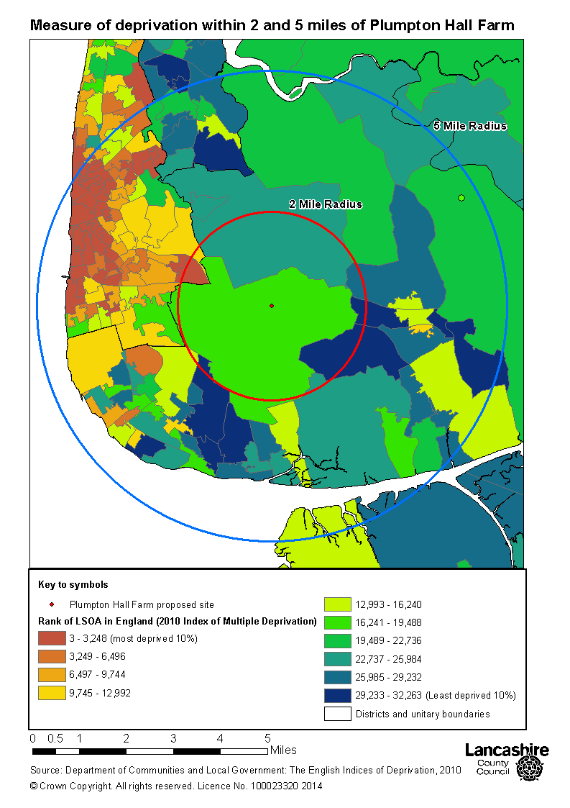

The proposed Plumpton Hall Farm site is in an LSOA that is in the least deprived 50% of all LSOAs in England. Similarly, the vast majority of surrounding area within a 2 mile radius is not deprived. To the west, the area covers most of an LSOA in Blackpool that is in the 10% most deprived in England.

The 5 mile radius area is very varied in terms of deprivation. Generally speaking it splits east to west. To the east, the LSOAs are mostly in the 50% least deprived in England. To the west, they are generally in the least deprived 50% of areas in England (with some exception in the north west and south west). Many of the areas in the west are in the 10% most deprived in England.

ProposedSite: Roseacre Wood

2 mile radius

The population within a 2 mile radius is 2,522.The gender split is almost equal. The population density of the area is 4.4 people per hectare. There are 539 people aged 0-19 years old within a 2 mile radius. They make up 21.4% of the area population. There are 1,501 people aged 20 to 64 years (59.5% of the population). 482 people are aged 65 and over (19.1% of the population).

Total population | Males | Females | Area (hectares) | Population density | 0-19 | 20-64 | 65+
2,522 | 1,235 | 1,287 | 3,628 | 4.37 | 539 | 1,501 | 482

Most of the population (2,088 people, 82.8%) did not have long-term conditions or health problems that limited their day-to-day activities. 187 people (7.4%) had day-to-day activities limited a lot and a further 247 (9.8%) people had them limited a little. Most of the population (2,083 people, 82.6%) had very good or good health. 427 people (17%) had very bad or bad health.

Day-to-day activities limited a lot | Day-to-day activities limited a little | Day-to-day activities not limited | Health – very good | Health – good | Health – fair | Heath – bad | Health – very bad
187 | 247 | 2,088 | 1,246 | 837 | 356 | 71 | 12

The population aged 16 to 74 years within a 2 mile is 1,890. 245 people (13%) are employed full time and 326 are retired (17%). Only 37 people (less than 2%) are unemployed.

All usual residents aged 16 to 74 | Economically active; employee; full-time | Economically active; unemployed | Economically inactive; retired
1,890 | 245 | 37 | 326

Mosaic analysis: 995 households (Mosaic)

Group 'country living' is dominant group at 618 households and at 62.1% is described above. Group 'rural reality' is second at 306 households and 30.8%. Described as householders living in inexpensive homes in village communities. The key features are:
- Rural locations;
- Village and outlying houses;
- Agricultural employment;
- Most are homeowners;
- Affordable value homes; and
- Slow Internet speeds.

5 mile radius

The population within a 5 mile radius is 39,132. The gender split is almost equal. The population density of the area is 23.8 people per hectare. There are 9,119 people aged 0-19 years old within a 5 mile radius. They make up 23.3% of the area population. There are 22,960 people aged 20 to 64 years (58.7% of the population). 7,053 people are aged 65 and over (18% of the population).

Total population | Males | Females | Area (hectares) | Population density | 0 - 19 | 20 - 64 | 65+
39,132 | 19,385 | 19,747 | 19,668 | 23.8 | 9,119 | 22,960 | 7,053

Most of the population (32,373 people, 82.7%) did not have long-term conditions or health problems that limited their day-to-day activities. 3,167 people (8.1%) had day-to-day activities limited a lot and a further 3,592 (9.2%) people had them limited a little. Most of the population (32,269 people, 82.5%) had very good or good health. 1,907 people (4.9%) had very bad or bad health.

Day-to-day activities limited a lot | Day-to-day activities limited a little | Day-to-day activities not limited | Health – very good | Health – good | Health – fair | Heath – bad | Health – very bad
3,167 | 3,592 | 32,373 | 19,166 | 13,103 | 4,956 | 1,510 | 397

The population aged 16 to 74 within a 5 mile radius is 29,001. 4,070 people (14%) are employed full time and 4,890 are retired (17%). 759 people (2.6%) are unemployed.

All usual residents aged 16 to 74 | Economically active; employee; full-time | Economically active; unemployed | Economically inactive; retired
29,001 | 4,070 | 759 | 4,890

Mosaic analysis: 16,426 households (Mosaic)

Group 'country living' is dominant at 21.6% and 3,546 households, second is 'rural reality' at 1,966 households and 12%, and 'suburban stability' group comes next at 11% and at 1,811 households, described as mature suburban owners living settled lives in mid-range housing, as outskirts of Preston fall within this radius. The key features are:
- Older families;
- Some adult children at home;
- Suburban mid-range homes;
- 3 bedrooms;
- Have lived at same address some years; and
- Research on internet.

Index of Multiple Deprivation 2010

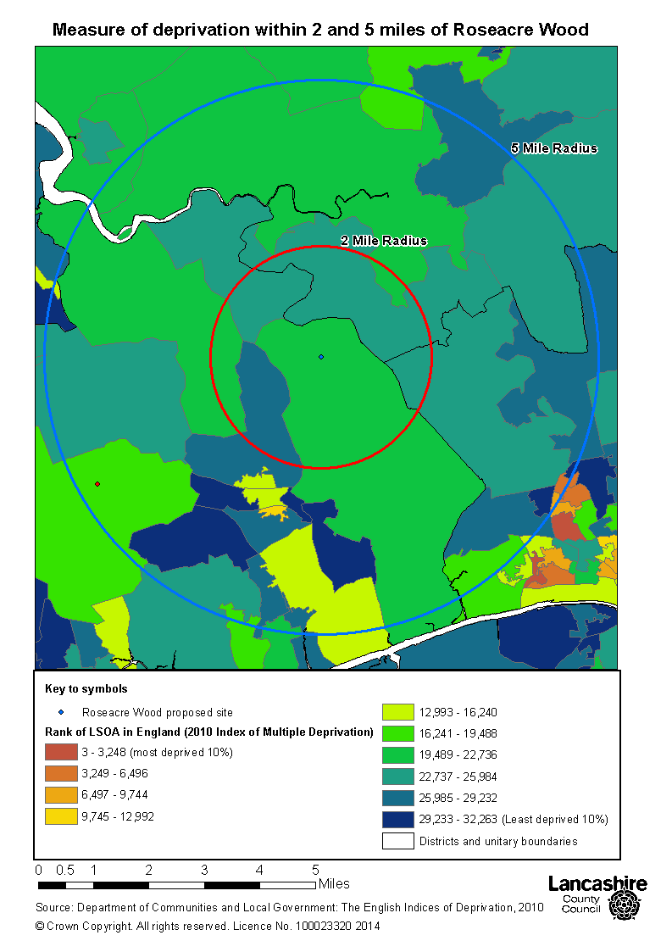

The proposed Roseacre Wood site is in an LSOA that is in the least deprived 50% of all LSOAs in England. Similarly, the surrounding area within a 2 mile radius is not deprived.

The vast majority of the 5 mile radius area is not deprived. Three areas fall just inside the 50% most deprived in England. One is in the 40% most deprived.

Fylde comparative data

At the 2011 Census, the population of Fylde was 75,757 people. Just over half (51%) were women.20% were aged 0-19 years old. 55% were aged 20 to 64 years and 24% were aged 65 or over.

Most of the population (78%) did not have their day-to-day activities limited by long-term conditions or ill health. 10% had their activities limited a lot and a further 11.5% were limited a little. 59,406 people (78.4%) had very good or good health. 4,732 (6%) people had very bad or bad health.

There were 54,544 residents aged 16 to 74 years old. 20,222 (37%) were employed full time and 11,262 (20.6%) were retired.1,687 people 3%) were unemployed.

Total population | Males | Females | Area (hectares) | Population density
75,757 | 36,781 | 38,976 | 16,569 | 36.0

0 - 19 | 20 - 64 | 65 and over
15,284 | 42,130 | 18,343

Day-to-day activities limited a lot | Day-to-day activities limited a little | Day-to-day activities not limited
7,849 | 8,714 | 59,194

Health – very good | Health – good | Health – fair | Heath – bad | Health – very bad
33,815 | 25,591 | 11,619 | 3,692 | 1,040

All usual residents aged 16 to 74 | Economically active; employee; full-time | Economically active; unemployed | Economically inactive; retired
54,544 | 20,222 | 1,687 | 11,262

ONS 2012 Mid-Year Population Estimate, Published November 2013
http://www.segmentationportal.com
Public Health England. (2014). Local Health. Available: http://www.localhealth.org.uk. Last accessed 30/09/2014.
Small Area Health Statistics Unit (SAHSU). (2014). The Environment and Health Atlas for England and Wales. Available: http://www.envhealthatlas.co.uk/. Last accessed 01/10/2014.
SMRs calculated by dividing the observed total deaths in the area by the expected deaths and multiplying by 100
The Lancashire county geography covers the Burnley, Chorley, Fylde, Hyndburn, Lancaster, Pendle, Preston, Ribble Valley, Rossendale, South Ribble, West Lancashire and Wyre districts
ONS 2012 Mid-Year Population Estimate, Published November 2013

